Nottingham Trent University

School of Science and Technology

**SOFT40151 – Mobile Interactive Systems**

Written By

*Manav Rachen (N0797516)*

LAB TUTOR: *Dr. Eiman Kanjo*

Table of Contents

Introduction and Background 4

Design 5

Key features of the app 5

Guidelines 6

Paper prototypes 8

Flow chart 9

Implementation 10

Login 10

Forgot password 10

Splash screen 11

Steps 11

Diary 11

Testing 12

Testing report 13

User Testing 13

Stage 1 13

Stage 2 15

Critique 17

References 18

Appendix 19

Personas 20

# List of Figures

Figure 1 Flow Chart

Figure 2

Figure 3

Figure 4

Figure 5

Figure 6

Figure 7

Figure 8

Figure 9

Figure 10 Personas 20

# List of Tables

Table 1 Key Features 5

Table 2 Testing Table 12

Table 3 User Testing 14

Table 4 User Testing 15

Table 5 Functional test 16

Table 6 Functional tests 16

# Introduction and Background

This document will explain the development process of the application called Fitness101 and this application targets users who enjoy the activity of running. In this document, we will be talking about how guidelines were followed to create this application this includes colour scheme, icons, font/size, layout, and many more. Next, we will be discussing how some features are implemented with some snippets of code showing how that part was implemented. The testing phase required two uses to test the application, a questionnaire was made to ask questions about the application two phases before and after. A critique section will be discussed in this section such as if development continued what additional feature would be added and what issues came up during the development of this application. Furthermore Android studio was used to create this application using the coding language Java.

# Design

This application called Fitness101 this app will allow runners to plan their route and keep track of how far the user ran, how many calories the user has burnt and how long they stopped while on the run. This will move away from apps that mainly focus on weight training but rely more on people who prefer to run.

## Key features of the app

|  |  |
| --- | --- |
| Gps Mapping | created a maps feature that runners can use to plan their routes before their run. |
| Audio | The maps feature has audio telling the user the direction he or she will take. |
| Database | The database stores information that the user may use or add in through diary entries this is saved using firebase. |
| Navigation Bar | The navigation bar on the left-hand side of every screen/page when clicked a draw feature will open the bar across the screen |
| BMI | Calculates the user's BMI from their height and weight |
| Diary | Users can keep track of how far they ran with any other information such as pictures of the route taken or how far they ran |
| Step Calculator/motion sensor | Tracks how many steps the user takes on their run |
| Gallery | Imports pictures from the user's gallery |
| Forgetting password | Resets user's passwords through email |
| Notifications | Using firebase to send notifications to all users |

Table Key Features

## Guidelines

This app used many guidelines used from Material Design. “Material is a design system created by Google to help teams build high-quality digital experiences for Android, iOS, Flutter, and the web.” (Material Design, N/A) A dark theme was used for this application as material design states “a dark theme surfaces across the majority of the app” (Material Design, N/A). This reduces eye strain and saves battery power, especially with devices with an OLED screen. The accent colour of the UI is a light yellow this stands out with the dark grey colour with the #121212 what recommended in the design guidelines for a dark theme, having a dark or a darker accent colour blends into the background which makes the content harder to see so the guidelines recommends using a brighter colour to make it stand out. The reason why black wasn't chosen #FFFFFF is that the colour black is very sharp and it needs to be a few shades lighter to match the accent colour of the application. The background colour is dark enough that the body of the text is bright enough to be seen without any issues.

The buttons on the application have a lighter grey colour compared to the background that creates a shadow that makes it stand out from what is referred to in the dark mode page of the guidelines. The font used within this app is san serif as it is simple and easy to read, this font is recommended by the guidelines. All icons used within this app are icons that are recommended by the material design guidelines. The icons used are icons that everyone knows such as the gear icon is always used for settings and a diary or book sections always refer to a book or some sort of diary icon. These will help the user understand what the page is and makes it look a lot more professional.

Navigation plays an important role throughout the application having a consistent design that is displayed on every screen can make life easy for the user to move to other pages of the application. In this app, the navigation button is 3 lines on the top left of the screen when this is clicked the lines will change to an arrow and a drawer screen will be displayed taking up half of the screen. Clicking on the 3 lines icon will close the screen allowing the user to see the home menu again. This screen contains buttons that the user can click to take them to the page they want to go on. As this is a simple design users will not have an issue learning the navigation this means they will not need to google or watch a tutorial on the application.

“White space is any section of a document that is unused or space around an object.” (Computer Hope, 2017) white space is an important feature that must be used properly such as in the spacing of the text. White space isn't necessarily a bad thing you do not want a page that is overly packed with information that is hard to read, but not too much space that the page looks empty with information. This application uses white space very well pages aren’t overly packed with information but full enough that the user can easily see what's going on without too much blank spacing around the content.

The app download size is not big meaning the user will not need to delete other applications on their phone to run this application as well as the speed of the application has a 2ms response rate and all buttons on the application does not exceed 3 or more clicks what is recommended on the system guidelines.

The application can run on all the latest android devices as well as the older generations such as the Samsung S4. Many people do not buy the latest android device on launch so having this application compatible with older generations will make the application have more users which will benefit the applicant's business.

“Selection refers to how users indicate specific items they intend to take action on.” (Material Design, N/A) entering selection mode is the mode where the user will press the button or the feature either for a short time or by tapping it. This application uses a short tap to use the functionality provided in this application.

“States are visual representations used to communicate the status of a component or interactive element.” (Material Design, N/A) A state has been used in the map feature. When the user loads up maps the button for navigation is disabled and has a greyed-out design as the guidelines recommend. When the user clicks on a destination the button fills in with a grey colour that shows it's active.

The sound uses informative-based audio that guides the user in the maps feature. The audio used is audio that gives the user directions while running.

Data or wifi will be needed for this application due to the database storage. For the app to check the user's credentials they must be connected to wifi so they can be checked or when the user makes an account for the application he or she requires wifi to allow the account to be made and saved to the database.

## Paper prototypes

Figure 2 shows the login page the user has 2 fields where they can enter their email and password. This page also contains 3 buttons that take the user to three different pages, forgot password, register, and log in.

Figure 3 shows the navigation feature. In this navigation bar, the user's name will be at the top below this has all the buttons of all the pages that the user can go to. This feature will be on all the pages that the user can go to.

Figure 4 is the about us page this page will be the home menu of the application.

Figure 5 is the diary page; users will be able to see the notes that they have created. They will also be able to edit and delete the notes they have created.

Figure 6 is the note page, this page allows users to import a picture and write a description that saves it.

Figure 7 is the maps feature in this application. A maps window is displayed where the user can move and zoom around the application. When a destination has been selected the user can click navigate and a route will be selected.

Figure 8 is the BMI page this page allows user to enter their height and weight this will calculate their overall BMI. The answer will be displayed below.

Figure 9 is the splash screen that appears when the application loads up this screen allows time for the rest of the app to load up.

## Flow chart

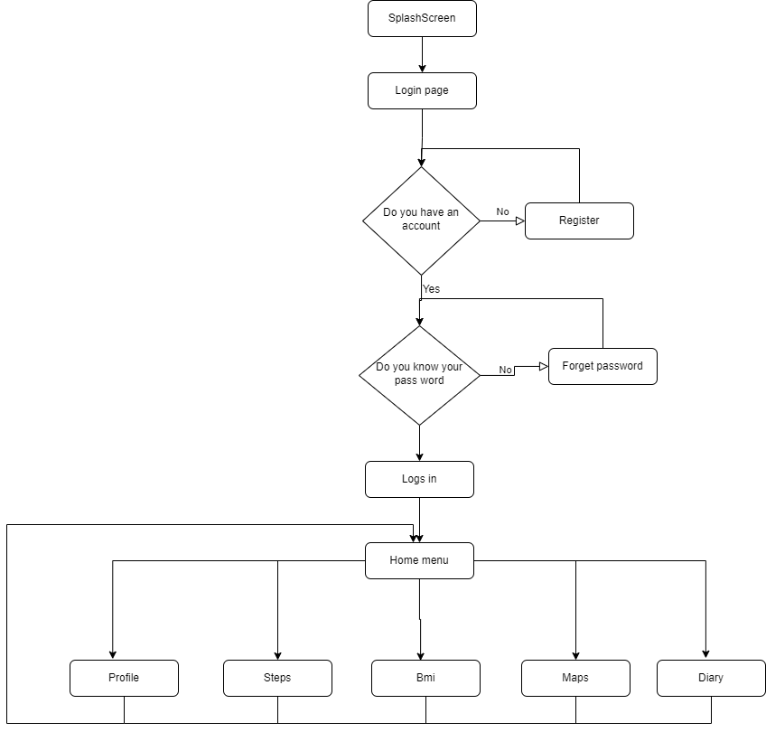

Figure Flow Chart

In this diagram, you can see the process of how a user would use this application and the steps he or she will take to enter the application. When the user launches the application, they will see the splash screen that lasts for 4 seconds. The user will be taken to the login page where they can reset their password, create an account, and finally log in. Once the user logs in they can access the home menu and all the other pages through the navigation bar.

# Implementation

## Login

This is the code that checks the fields when the login button is pressed if these fields are empty the user will not get logged in.

if(Email.isEmpty()){  
 editTextEmail.setError("Email is Required");  
 editTextEmail.requestFocus();  
 };

However, the user will not know why they weren’t allowed to log in, so a prompt had to be added letting the user know why they weren’t allowed to enter the application. This was also done for the password field as well.

if(!Patterns.*EMAIL_ADDRESS*.matcher(Email).matches()){  
 editTextEmail.setError("Please enter a valid email address");  
 editTextEmail.requestFocus();  
}

This section of the code adds validation checking that gives the user a prompt if an invalid email account or password has less than 6 characters a prompt will appear. However, this hasn’t got anything to do with checking the user's actual details that are saved on firebase.

if(task.isSuccessful()){  
 startActivity(new Intent(Login.this, MainActivity.class));

A class was made to check the users’ credentials if the credentials were correct the user will be taken to the main menu where they can use the functionality of the app. If the credentials are wrong a prompt will appear saying failed to log in a check your credentials.

## Forgot password

Forgot password was implemented due to the testing phase as one of the testers forgot their password and had to make a new account.

auth.sendPasswordResetEmail(Email).addOnCompleteListener(new OnCompleteListener<Void>()

A function was created to send the user an email to reset their password if their email is on the database.

if(task.isSuccessful()){  
 Toast.*makeText*(ForgetPassword.this, "check your email to reset your password",Toast.*LENGTH_LONG*).show();  
 progressBar.setVisibility(View.*GONE*);

If the email is on the database an email will be sent to the user where the user can reset their password what updates the database. If the email is wrong a prompt will pop up saying, try again.

## Splash screen

A splash screen was added to allow the application to load up in the background. A variable was set to time the screen, once the time has run out the screen will change to the login screen.

public static int *SPLASH_TIME_OUT* =4000;

public void run() {  
 Intent homeIntent = new Intent(SplashScreen.this, Login. Class);  
 startActivity(homeIntent);  
 finish();  
}

## Steps

Steps was implemented to calaculate the runers steps this is done through the phones motion sensor.

running = true;  
Sensor countSensor = sensorManager.getDefaultSensor(Sensor.*TYPE_STEP_COUNTER*);

This section shows that if the user is running then the sensor will be activated. If there is no sensor on the device a prompt will appear teeling a the user saying a sensor has not been found. The number will increase based on the users movement.

## Diary

The diary consists of 2 java classes and 2 activities. The note activity allows the user to write and upload a image the diary activity allows the user to open and store their entrys what can be opened up.

Intent intent = new Intent(getApplicationContext(),Note.class);  
 intent.putExtra("noteId", i);  
 startActivity(intent);  
}

This shows that when the user ads a new note or creates a note they will be taken to the note page.

static ArrayList<String> *notes* = new ArrayList<>();

All the notes are stored within an array. Deleting notes removes the note from this array what removes it from the activity.

# Testing

Tests were carried out throughout the development of this application such as functionality testing. Using a testing table as shown below, this table allowed me to write the type of test and keep track of all the functionality that works and doesn’t work.

|  |  |  |  |
| --- | --- | --- | --- |
| Id | Test | Predicted outcome | Actual outcome |
| 1 | Testing is the user can register an account | The user can enter their details when the register is clicked an account is made | Success |
| 2 | Testing to see if the user Log in | If the user has an account the user can log in by clicking log in which takes the user to a new page | Success |
| 3 | Testing if the user navigating to other pages | Users should be able to navigate through the app by clicking on the page they would like to go on | Fail- app crashed when buttons are pressed |
| 4 | Testing if the user navigating to other pages | Users should be able to navigate through the app by clicking on the page they would like to go on | Success- Buttons weren’t connected properly to the page |
| 5 | Testing to see if the user can make a new note entry | The user should be able to click on the 3 dots to create a note note | Success |
| 6 | Testing to see if the user can View a note entry | Users can click on the note to view the details or edit the note | Success |
| 7 | Testing to see if the user can delete an entry | When the user clicks and holds on the diary entry a pop up should appear allowing the user to delete the entry | Success |
| 8 | Testing to see if the user enter information in a text view | This test checks that all the edited texts and text view display and allows the user to enter text what saves into the app | Success |

Table Testing Table

## Testing report

This phase asked 2 users for their opinion on the application. A few changes have been described such as the navigation feature not being the same on every page as well as the delay of the navigation feature appearing out. A few more features need to change such as the layout out of the text boxes and edit texts. The spacing between these fields is inaccurate meaning one is higher than the other, so this also needs to be changed to make the application professional. More functionality is needed the application is currently quite baren so additional functionality is required. Colour scheme needs to change due to the background and accent colours do not match the background colour being too bright making the text hard to read.

## User Testing

### Stage 1

|  |  |  |
| --- | --- | --- |
| Question | User 1 | User 2 |
| What do you think of the colour scheme? | Colours don’t match and are too hard to read the text due to the sharpness of the background | The colours are very strange, and it doesn’t look professional |
| What do you think of the text size | Text size is big enough that it is easy to read | The text is clear and easy to read |
| What do you think of the navigation? | The navigation is simple but on some pages the text is spelled wrong as well | The navigation draw time is very delayed. |
| What do you think about the layout? | The layout for the login screen is good however the layout for the register screen isn’t accurate enough the boxes are uneven | The layout out is good but inconsistent throughout the app |
| What do you think of the functionality? | It’s a good start for functionality but more functionality is needed | More functionality is needed but for now log in, register, and forgot password is fully functional. |
| What do you think of the font? | The font is good easy to read however slightly boring | The font is simple and easy to read |
| What do you think of the name of the application? | The name of the application is good and describes the app well | The application name is good and simple |
| Do you think a splash screen should be added? | Yes this will make the application look more professional | Yes it will make the app load everything up while the splash screen is up |

Table User Testing

This is the second phase of testing the same two users were asked to carry out the questionnaire. A few more issues have come out such as adding a profile section where the user can see their details and edit them. The buttons do not look like a button so it may confuse users where to click so adding in a border that’s a slightly different colour will allow users to differentiate where to click to continue to the next slide. Adding a forgot password slide will allow the user to reset their password, an email will be sent to the user if their email is in the database. A settings page has been added where the user can log out of the application.

### Stage 2

|  |  |  |
| --- | --- | --- |
| Question | User 1 | User 2 |
| What do you think of the colour scheme? | The colour scheme is a lot better going for dark mode was a good idea | The dark mode is a good choice due to many people prefer using dark mode |
| What’s do you think of the navigation? | Navigation is a lot better looks the same on all pages | The navigation speed on the drawer has increased and not delayed anymore |
| What do you think about the layout? | The layout has now been updated and looks a lot better than the previous test | The layout has now been updated and looks consistent throughout the app |
| What do you think of the note page? | This page is well made. It supports the theme very well and they're a lot of space to write in | Adding in an image is a good idea as some people would like to add a photo to describe that specific note |
| What do you think of the diary functionality? | Viewing each note and how it's all laid out is very simple and easy to understand | Deleting and adding notes is very simple |
| What do you think of the map's functionality? | Maps are very easy to use and the navigate button hiding and appearing is a good feature to have | Reporting a problem is a good feature as the maps change direction due to the issue straight away |
| Should there be a profile page? | Having a profile page is good since they can update it | Yes the application should have a profile page that shows details of the user's account |
| Are the buttons fine? | The buttons should change they look more like a word than a button so users may get confused on where to click | Having a border around the text shows where the user can click to move onto the next page |
| Any other features that should be added? | Forgot password should be made | A settings page or a log-out button should be made. |

Table User Testing

The functional unit test was also carried out during the development stage of the application the tables below are some examples of testing for the functionality. Some of the tests failed this allowed me to keep track of what functionality worked and what needed more time to work on.

|  |  |  |  |  |
| --- | --- | --- | --- | --- |
| ID | 1 | Description: | | Testing to see Login Button Checks details if they are correct or incorrect |
| Test Type | Unit test | Success criteria: | Button changes screen to login | |
| Number of Attempts | 1 | Comments: |  | |
| List of Equipment / Requirements: | Android Studio | | | |
| Setup Instructions: | Load up the application enter users’ emails and password | | | |
| Failure correction procedure: |  | | | |
| Engineer(s)/Technician(s): | Manav Rachen | | | |
| Individual results: | Pass | | | |
| Test Date: | 10/2/2022 | Result: | Pass | |

Table Functional test

|  |  |  |  |  |
| --- | --- | --- | --- | --- |
| ID | 2 | Description: | | Register user |
| Test Type | Unit test | Success criteria: | When a user adds in their details and clicks register an account should be made in a firebase | |
| Number of Attempts | 1 | Comments: |  | |
| List of Equipment / Requirements: | Android studio | | | |
| Setup Instructions: | Load up the application click on the register | | | |
| Failure correction procedure: |  | | | |
| Engineer(s)/Technician(s): | Manav Rachen | | | |
| Individual results: | Pass | | | |
| Test Date: | 20/2/2022 | Result: | Pass | |

Table Functional tests

# Critique

For future improvements having the application have a calorie calculator where they can record their food and water intake. Having a list of foods that have already been added can make it easier for clients to add their food in however an option can be added where the client can add their food that might not be on the list manually or through a barcode that they can scan what adds in the calories of that specific good type.

Taking into consideration of the running side this will automatically deduct the number of calories that have been burnt through the steps taken so the user knows how much food they can eat. Leading on from this point in the future the user can see if their Bmi is healthy if not they can enter their weight and their target weight and the app can calculate how many calories the user can eat.

For the diary currently, the user can import any picture but in the future, the track that the user selects to run automatically saves the track and imports it to the diary with runtime, the distance, and a section where the user can add in other details.

Adding a light mode to the application will allow the user to decide what they want to use not everyone enjoys dark mode so having the option of both themes will make everyone happy.

There are a few features that caused many issues within this app such as the navigation feature. using a fragment that is called on every page didn’t work it crashed the app as well as it didn’t allow the user to travel from page to page. Eventually having to make a new activity and calling that activity on each page allowed the bar to appear and allowed the user to travel from page to page.

Another issue that didn’t work was recalling the time and distance of the map and entering those details in the diary this caused many issues and it didn’t work due to having issues storing that data onto the database.

# References

Computer Hope, 2017. *White space.* [Online]   
Available at: https://www.computerhope.com/jargon/w/whitspac.htm  
[Accessed 28 2 2022].

Material Design, N/A. *Material System.* [Online]   
Available at: https://material.io/design/introduction  
[Accessed 21 02 2022].

# Appendix

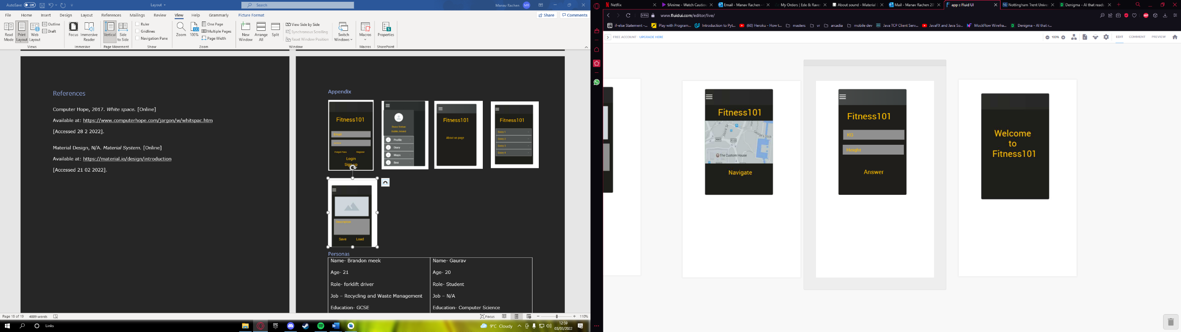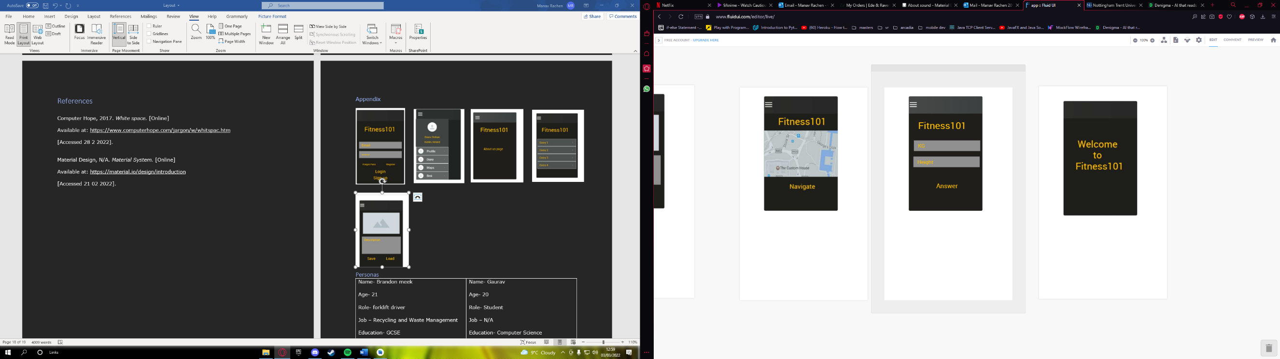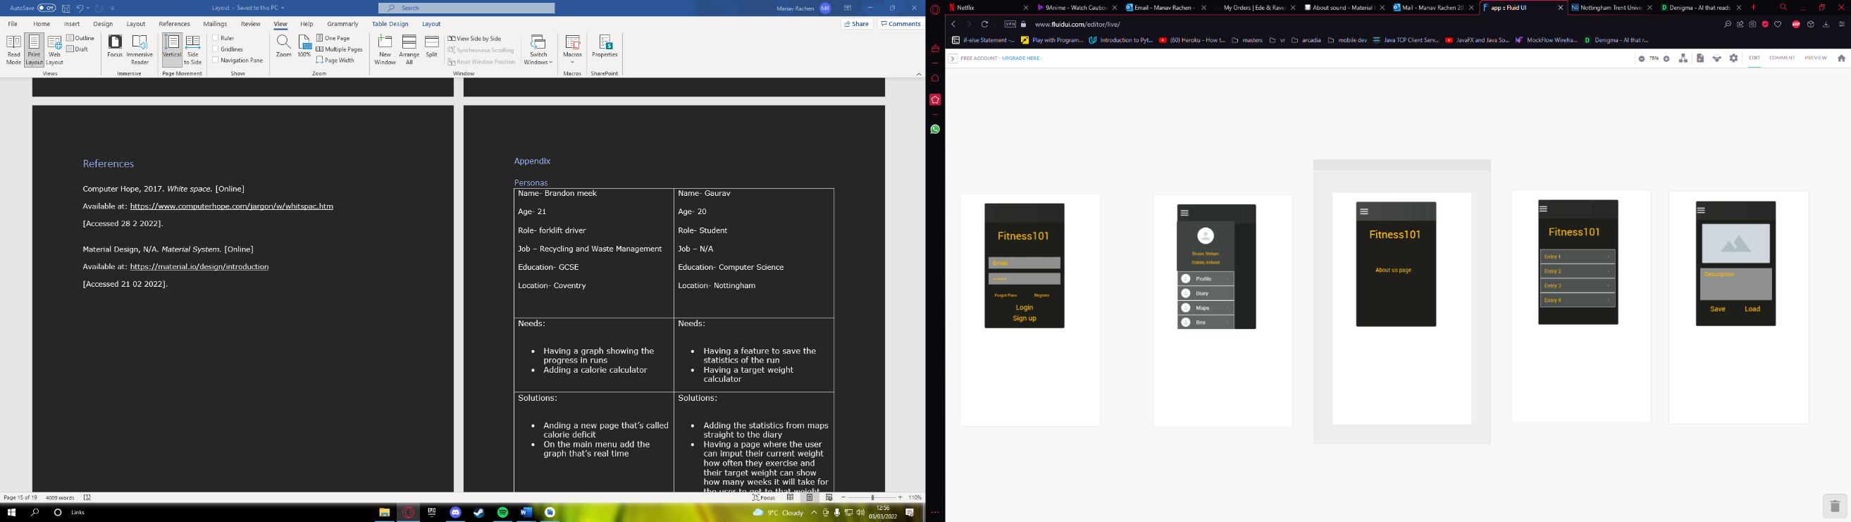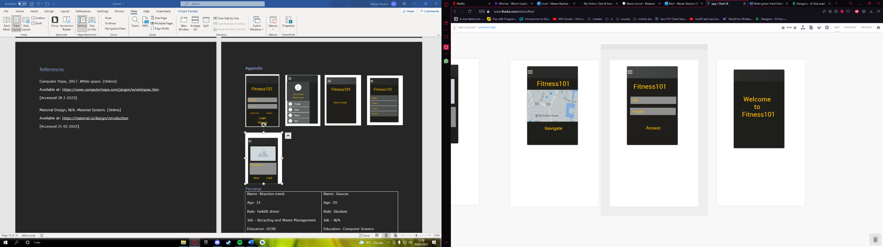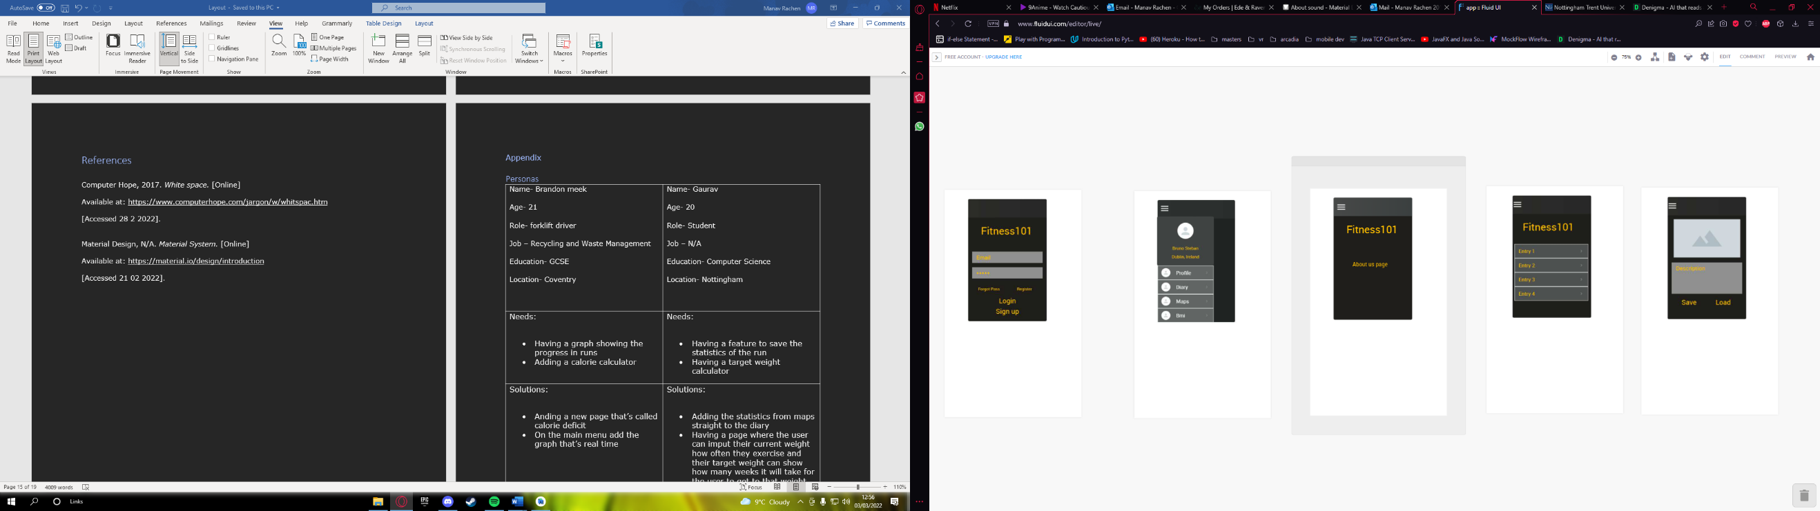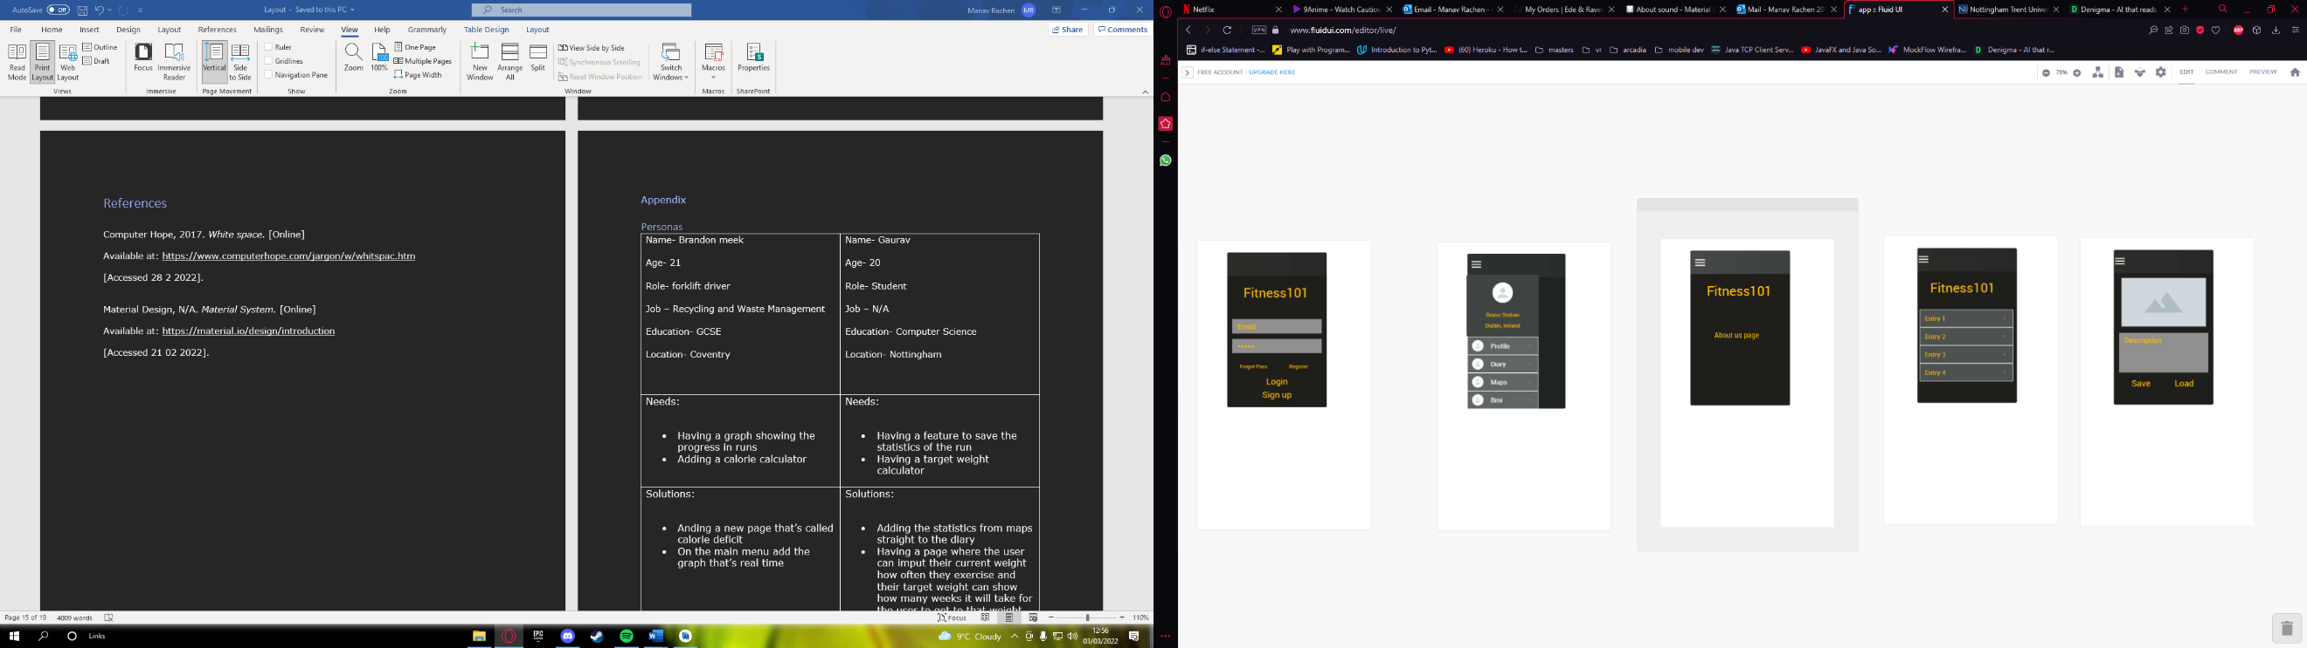

Figure

Figure

Figure

Figure

Figure

Figure

Figure

Figure

## Personas

|  |  |
| --- | --- |
| Name- Brandon meek  Age- 21  Role- forklift driver  Job – Recycling and Waste Management  Education- GCSE  Location- Coventry | Name- Gaurav  Age- 20  Role- Student  Job – N/A  Education- Computer Science  Location- Nottingham |
| Needs:   * Having a graph showing the progress in runs * Adding a calorie calculator | Needs:   * Having a feature to save the statistics of the run * Having a target weight calculator |
| Solutions:   * Anding a new page that’s called calorie deficit * On the main menu add the graph that’s real time | Solutions:   * Adding the statistics from maps straight to the diary * Having a page where the user can imput their current weight how often they exercise and their target weight can show how many weeks it will take for the user to get to that weight. |

Figure 10 Personas